**VISVESVARAYA TECHNOLOGIVAL UNIVERSITY**

“JNANASANGAMA”, Belgaum- 590014, Karnataka



LAB REPORT

ON

**OBJECT ORIENTED JAVA PROGRAMMING**

(23CS3PCOOJ)

*Submitted By*

**DISHA D S**

**(1BM23CS094)**

*in partial fulfilment for the award of the degree of*

BACHELOR OF ENGINEERING

IN

**COMPUTER SCIENCE AND ENGINEERING**



**BMS COLLEGE OF ENGINEERING**

(Autonomous Institute under VTU)

Bengaluru- 560019

Sep- 2024 to Jan- 2025

**B.M.S. College of Engineering,**

**Bull Temple Road, Bangalore 560019**

(Affiliated To Visvesvaraya Technological University, Belgaum)

**Department of Computer Science and Engineering**



This is to certify that the Lab work entitled “Object Oriented Java Programming (23CS3PCOOJ)” carried out by **DISHA D S (1BM23CS094),** who is bonafide student of **B.M.S. College of Engineering.** It is in partial fulfilment for the award of **Bachelor of Engineering in Computer Science and Engineering** of the Visvesvaraya Technological University, Belgaum. The Lab report has been approved as it satisfies the academic requirements in respect of an Object Oriented Java Programming (23CS3PCOOJ) work prescribed for the said degree.

|  |  |
| --- | --- |
| Lab faculty Incharge Name  Assistant Professor  Department of CSE, BMSCE | Dr. Kavita Sooda  Professor & HOD  Department of CSE, BMSCE |

**Index**

|  |  |  |  |
| --- | --- | --- | --- |
| **Sl.**  **No.** | **Date** | **Experiment Title** | **Page No.** |
| 1 | 1/10/2024 | Program to find Solution of a Quadratic equation | 4 |
| 2 | 8/10/24 | Program to find SGPA | 7 |
| 3 | 15/10/24 | Program to take book details and display | 14 |
| 4 | 22/10/24 | Find area of shapes by implementing abstract class | 22 |
| 5 | 29/10/24 | Bank Program | 28 |
| 6 | 12/11/24 | Packages implementation to display final marks | 32 |
| 7 | 26/11/24 | Implementation of Exceptions | 40 |
| 8 | 3/12/24 | Implementation of threads on printing BMS & CSE | 44 |
| 9 | 3/12/24 | Creating a user interface to perform integer division | 48 |
| 10 |  |  |  |

PROGRAM 1

Develop a Java program that prints all real solutions to the quadratic equation ax2 +bx+c = 0. Read in a, b, c and use the quadratic formula. If the discriminate b2 -4ac is negative, display a message stating that there are no real solutions.

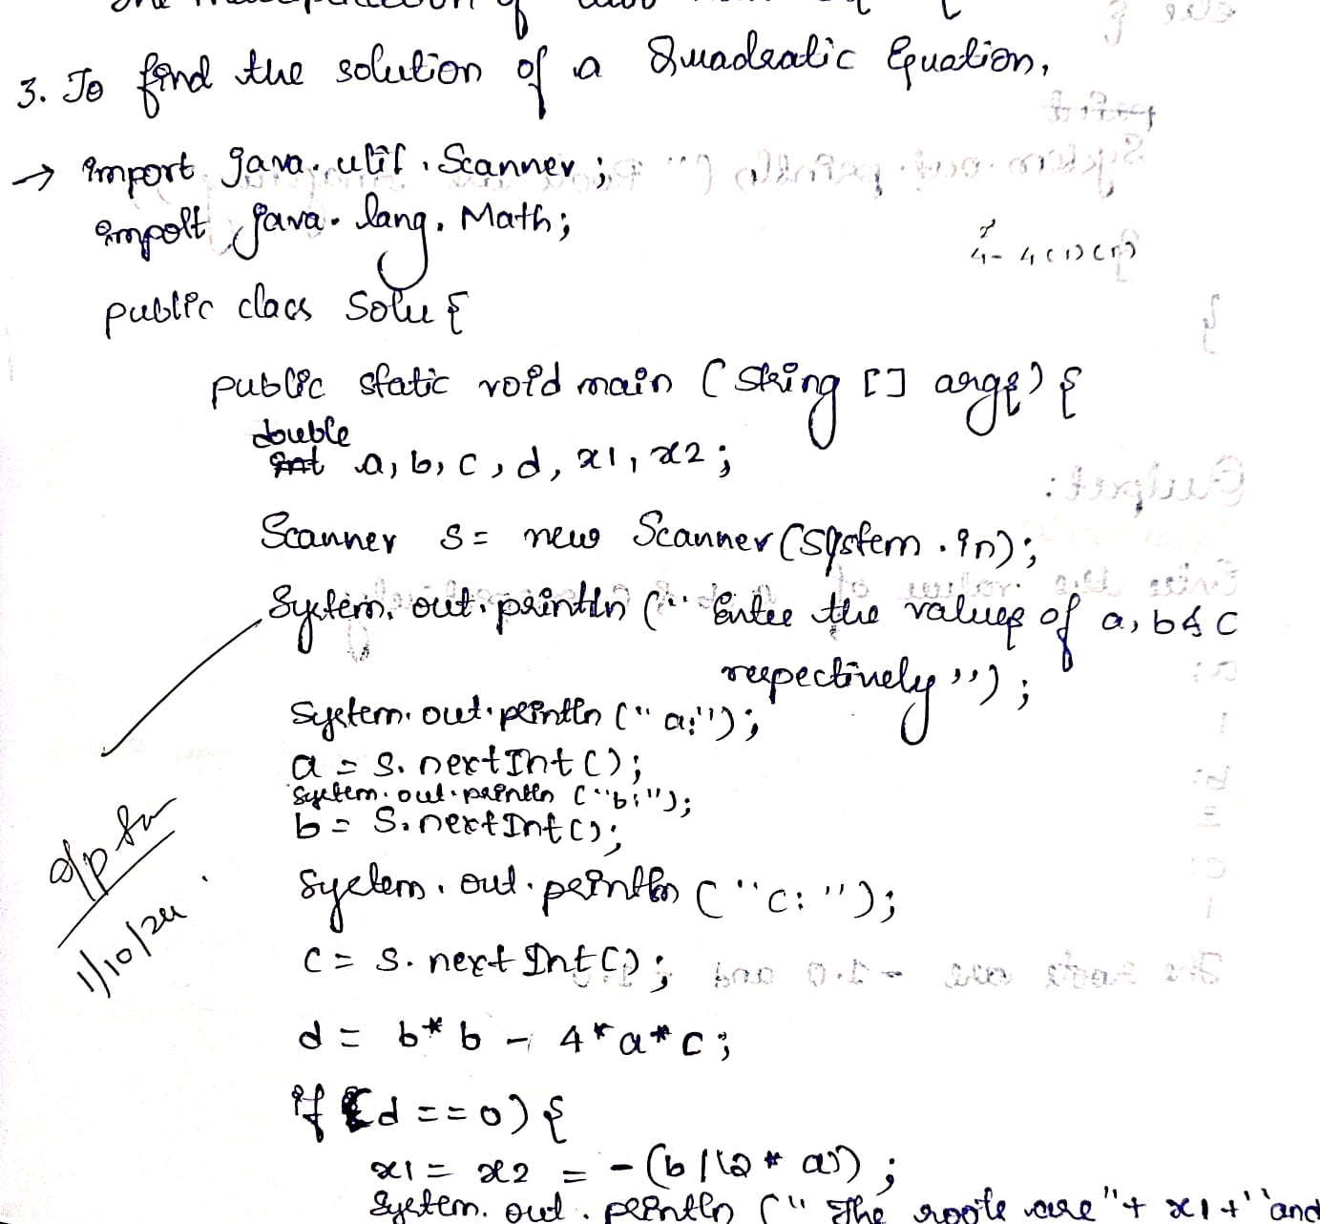

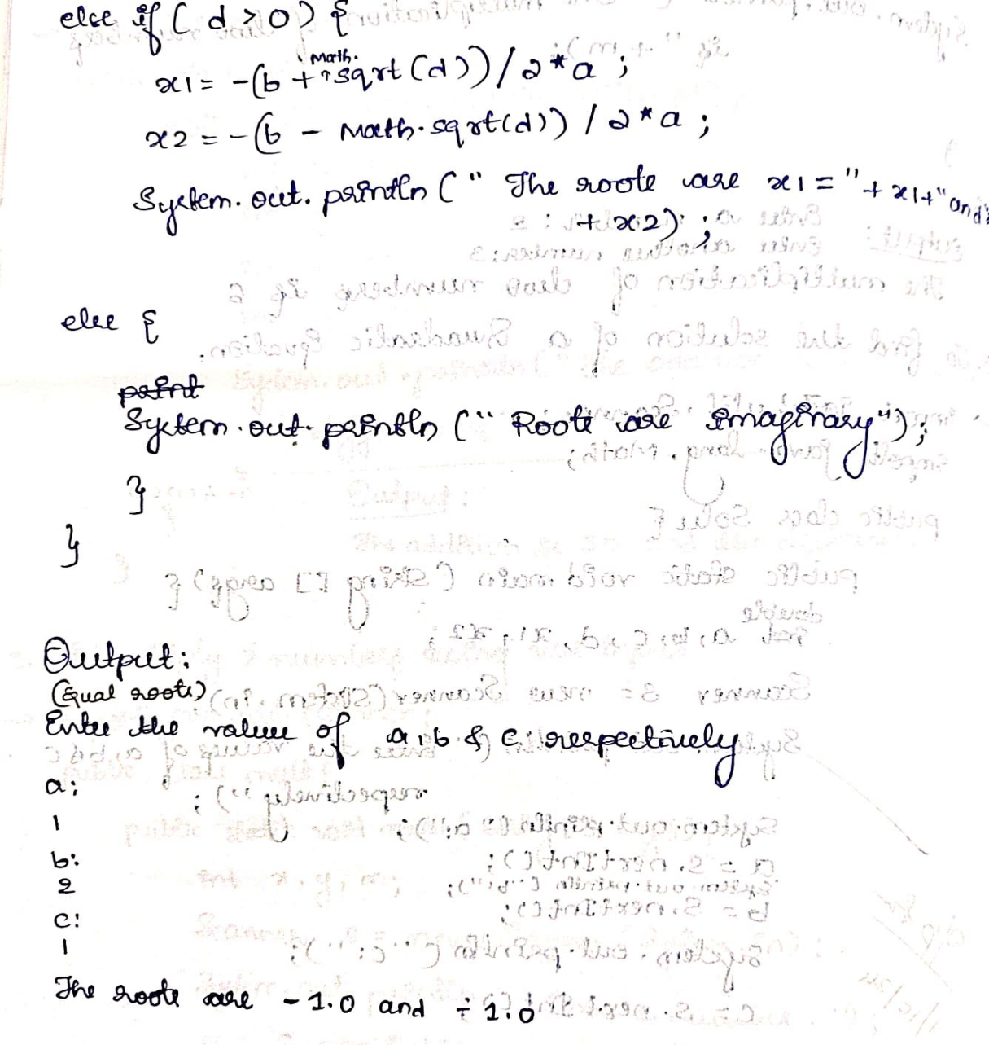

import java.util.Scanner;

public class Solu{

    public static void main(String args[]){

        double a,b,c,d,x1,x2;

        Scanner s = new Scanner(System.in);

        System.out.println("Enter the values of a ,b and c respectively ");

        System.out.print("a: ");

        a= s.nextInt();

        System.out.print("b: ");

        b=s.nextInt();

        System.out.print("c: ");

        c= s.nextInt();

        d = b*b-4*a*c;

        if(d==0)

        {

            x1=x2=-(b/(2*a));

            System.out.println("The roots are"+x1+"and"+x2);

        }

        else if(d>0)

        {

            x1=-(b+Math.sqrt(d))/2*a;

            x2=-(b-Math.sqrt(d))/2*a;

            System.out.println("The roots are"+x1+"and"+x2);

        }

        else{

            System.out.println("Roots are imaginary");

        }

    }

}

***OUTPUT:***

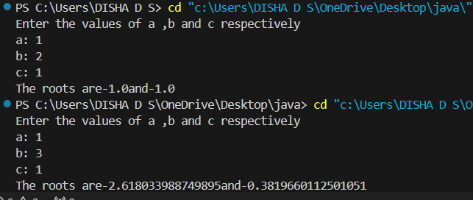

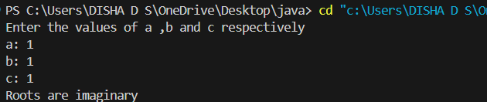

PROGRAM 2

Develop a Java program to create a class Student with members usn, name, an array credits and an array marks. Include methods to accept and display details and a method to calculate SGPA of a student.

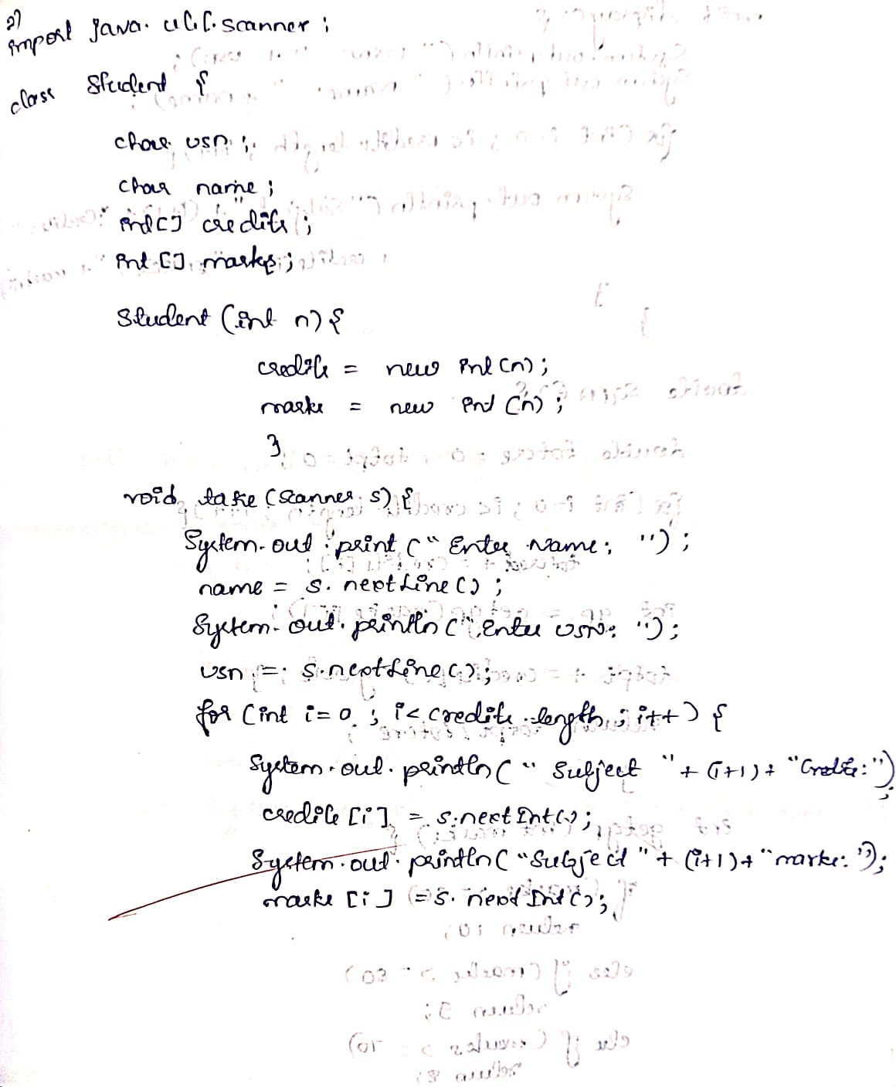

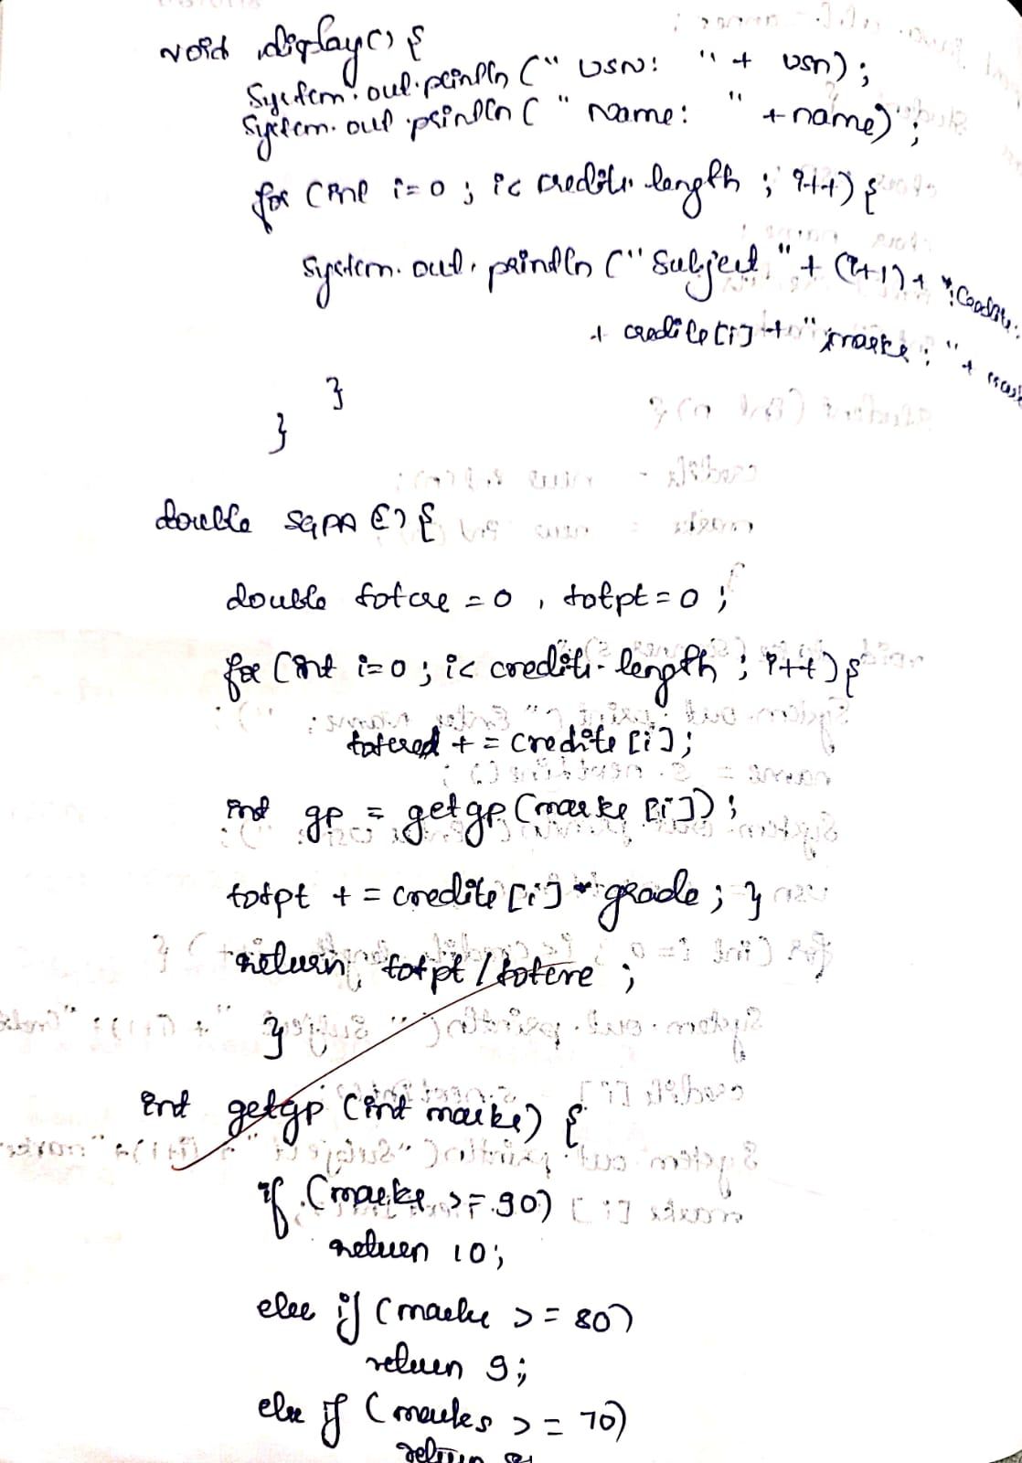

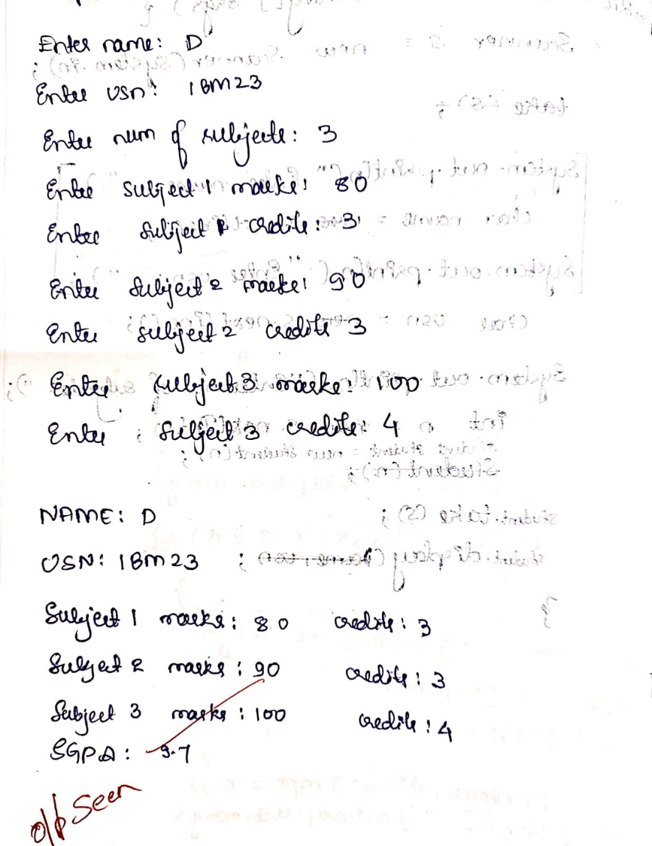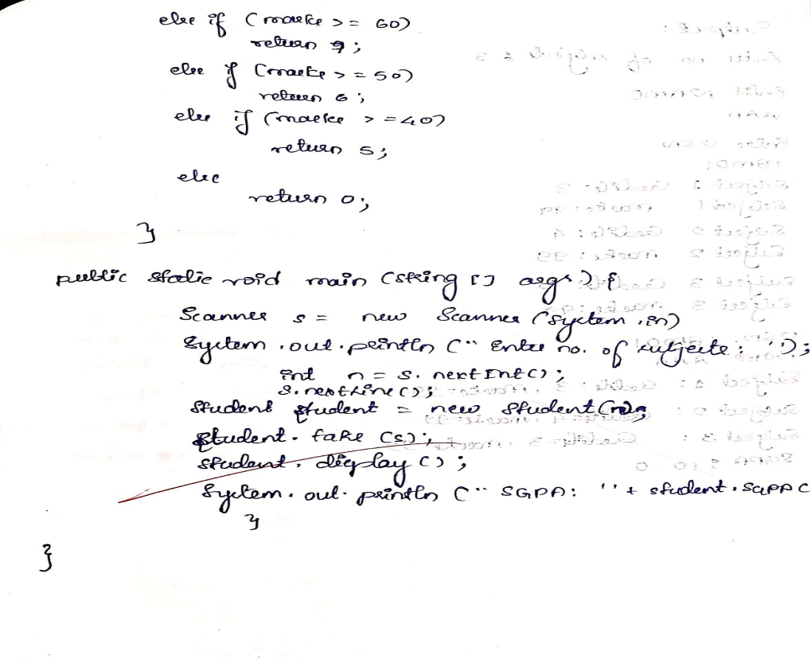

Program:

import java.util.Scanner;

class Student {

    String usn;

    String name;

    int[] credits;

    int[] marks;

    Student(int n) {

        credits = new int[n];

        marks = new int[n];

    }

    void take(Scanner s) {

        System.out.println("ENTER NAME: ");

        name = s.nextLine();

        System.out.println();

        System.out.println("ENTER USN: ");

        usn = s.nextLine();

        for (int i = 0; i < credits.length; i++) {

            System.out.print("Subject " + (i + 1) + " Credits: ");

            credits[i] = s.nextInt();

            System.out.print("Subject " + (i + 1) + " Marks: ");

            marks[i] = s.nextInt();

        }

    }

    void display() {

        System.out.println("USN: " + usn);

        System.out.println("Name: " + name);

        for (int i = 0; i < credits.length; i++) {

            System.out.println("Subject " + (i + 1) + ": Credits=" + credits[i] + ", Marks=" + marks[i]);

        }

    }

    double SGPA() {

        double totcre = 0;

        double totpt = 0;

        for (int i = 0; i < credits.length; i++) {

            totcre += credits[i];

            int gp = getgp(marks[i]);

            totpt+= credits[i] * gp;

        }

        return totpt / totcre;

    }

    // Helper method to convert marks to grade

    int getgp(int marks) {

        if (marks >= 90) return 10;

        else if (marks >= 80) return 9;

        else if (marks >= 70) return 8;

        else if (marks >= 60) return 7;

        else if (marks >= 50) return 6;

        else if (marks >= 40) return 5;

        else return 0;

    }

    public static void main(String[] args) {

        Scanner s = new Scanner(System.in);

        System.out.print("Enter no. of subjects: ");

        int n = s.nextInt();

        s.nextLine();

    Student student = new Student(n);

        student.take(s);

        student.display();

        System.out.println("SGPA: " + student.SGPA());

    }

}

Output:

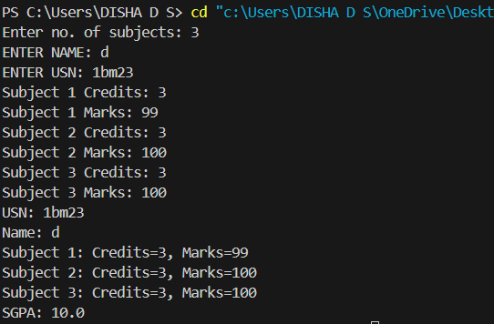

Program 3

Create a class Book which contains four members: name, author, price, num_pages. Include a constructor to set the values for the members. Include methods to set and get the details of the objects. Include a toString( ) method that could display the complete details of the book. Develop a Java program to create n book objects.

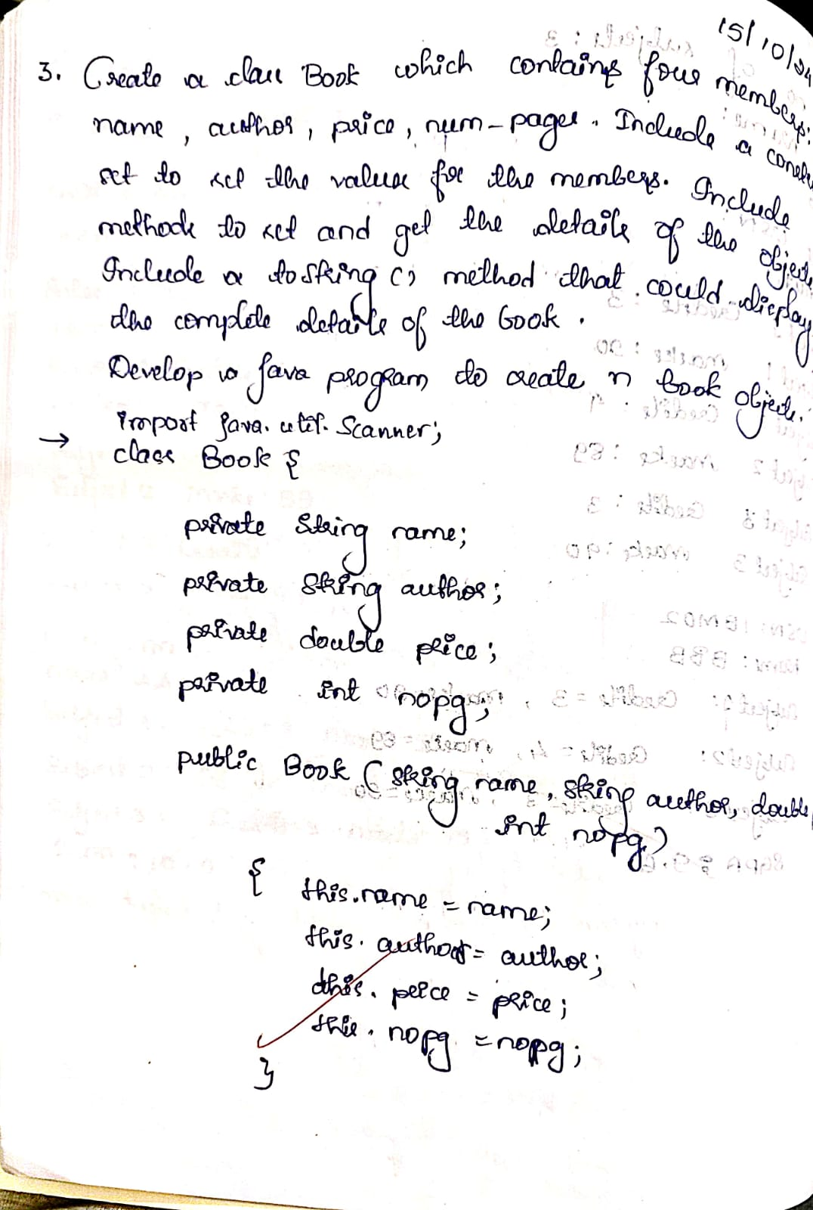

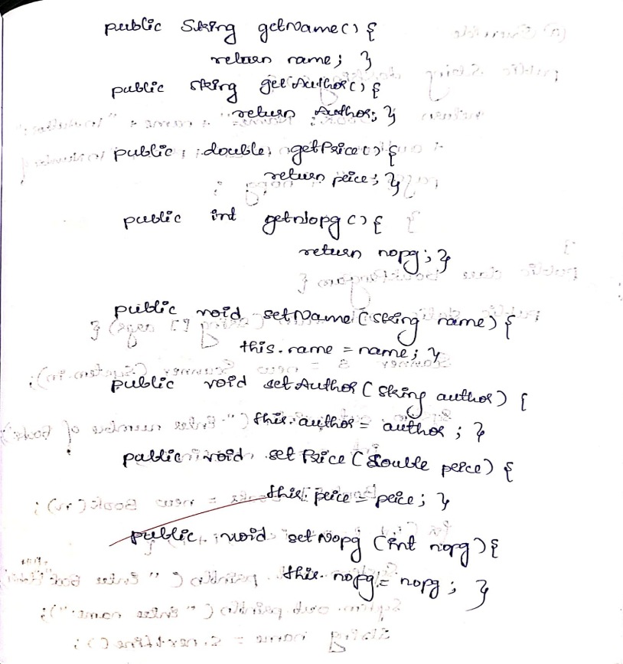

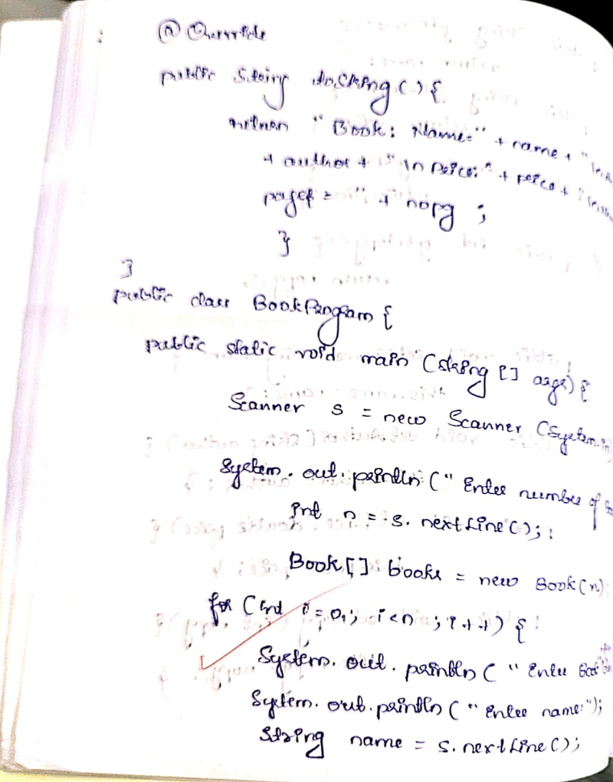

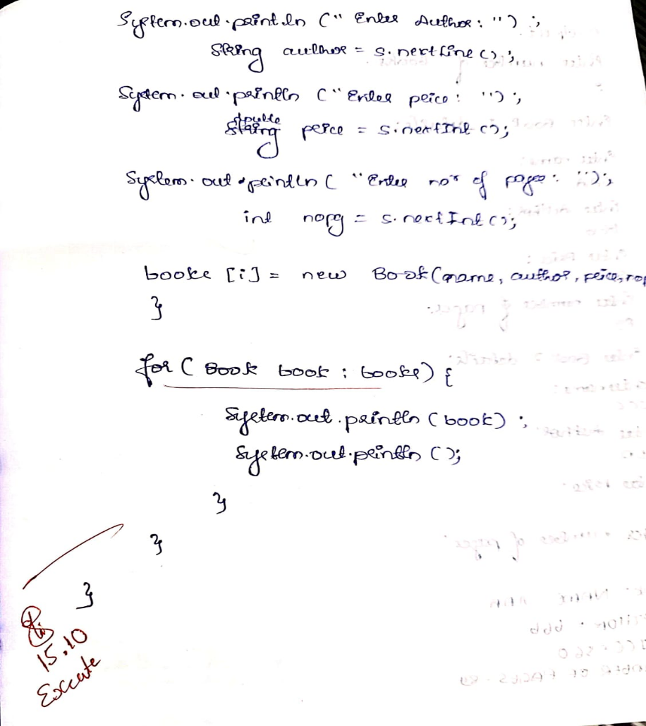

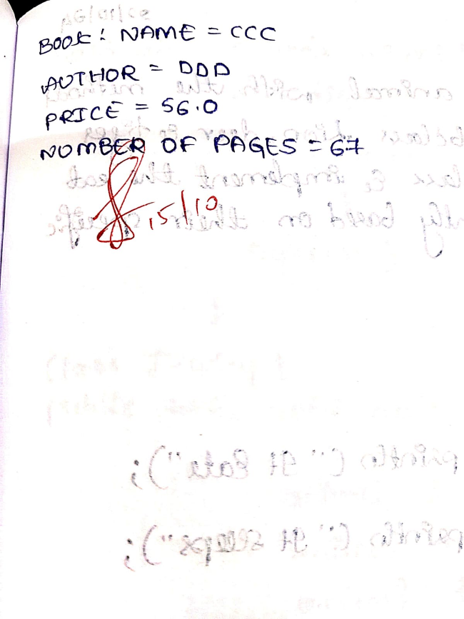

Program:

import java.util.Scanner;

class Book{

    private String name;

    private String author;

    private double price;

    private int numPages;

    public Book(String name, String author, double price, int numPages) {

        this.name = name;

        this.author = author;

        this.price = price;

        this.numPages = numPages;

    }

    public void setName(String name) {

        this.name = name;

    }

    public void setAuthor(String author) {

        this.author = author;

    }

    public void setPrice(double price) {

        this.price = price;

    }

    public void setNumPages(int numPages) {

        this.numPages = numPages;

    }

    public String getName() {

        return name;

    }

    public String getAuthor() {

        return author;

    }

    public double getPrice() {

        return price;

    }

    public int getNumPages() {

        return numPages;

    }

    @Override

    public String toString() {

        return "Book Details:\n" +

               "Name: " + name + '\n' +

               "Author: " + author + '\n' +

               "Price: $" + price + '\n' +

               "Number of Pages: " + numPages;

    }

}

public class BookProgram{

    public static void main(String[] args) {

        Scanner scanner = new Scanner(System.in);

        System.out.print("Enter the number of books to create: ");

        int n = scanner.nextInt();

        scanner.nextLine();

        Book[] books = new Book[n];

        for (int i = 0; i < n; i++) {

            System.out.println("\nEnter details for book " + (i + 1) + ":");

            System.out.print("Enter name: ");

            String name = scanner.nextLine();

            System.out.print("Enter author: ");

            String author = scanner.nextLine();

            System.out.print("Enter price: ");

            double price = scanner.nextDouble();

            System.out.print("Enter number of pages: ");

            int numPages = scanner.nextInt();

            scanner.nextLine();

            books[i] = new Book(name, author, price, numPages);

        }

        System.out.println("\nDetails of all books:");

        for (int i = 0; i < n; i++) {

            System.out.println("\nBook " + (i + 1) + ":");

            System.out.println(books[i].toString());

        }

        scanner.close();

    }

}

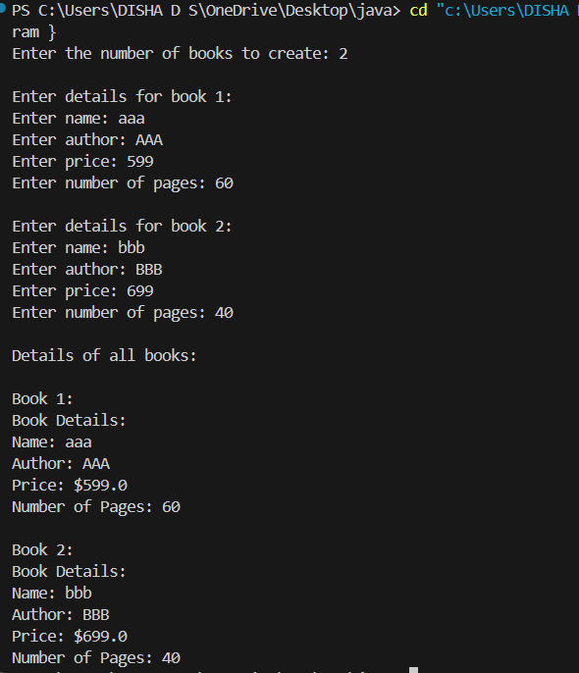

Program 4

Develop a Java program to create an abstract class named Shape that contains two integers and an empty method named printArea( ). Provide three classes named Rectangle, Triangle and Circle such that each one of the classes extends the class Shape. Each one of the classes contain only the method printArea( ) that prints the area of the given shape

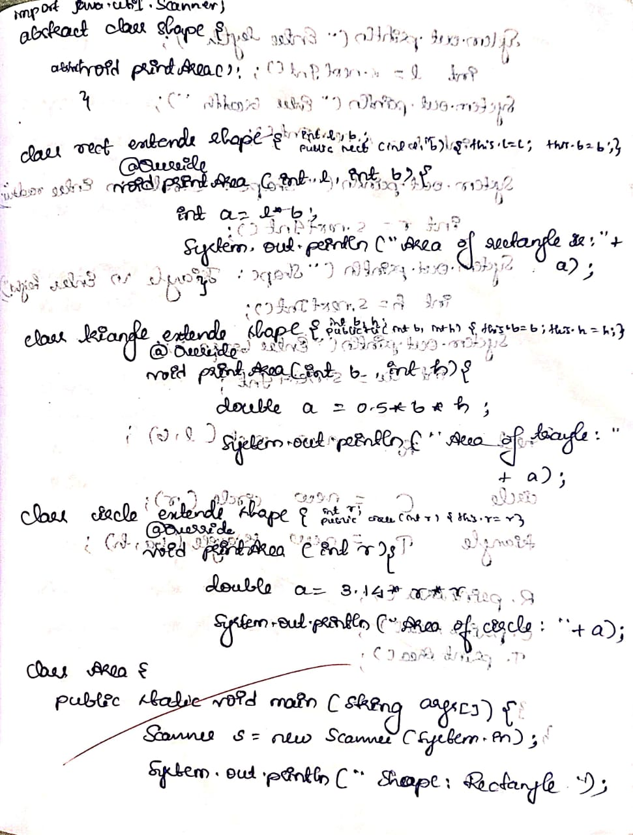

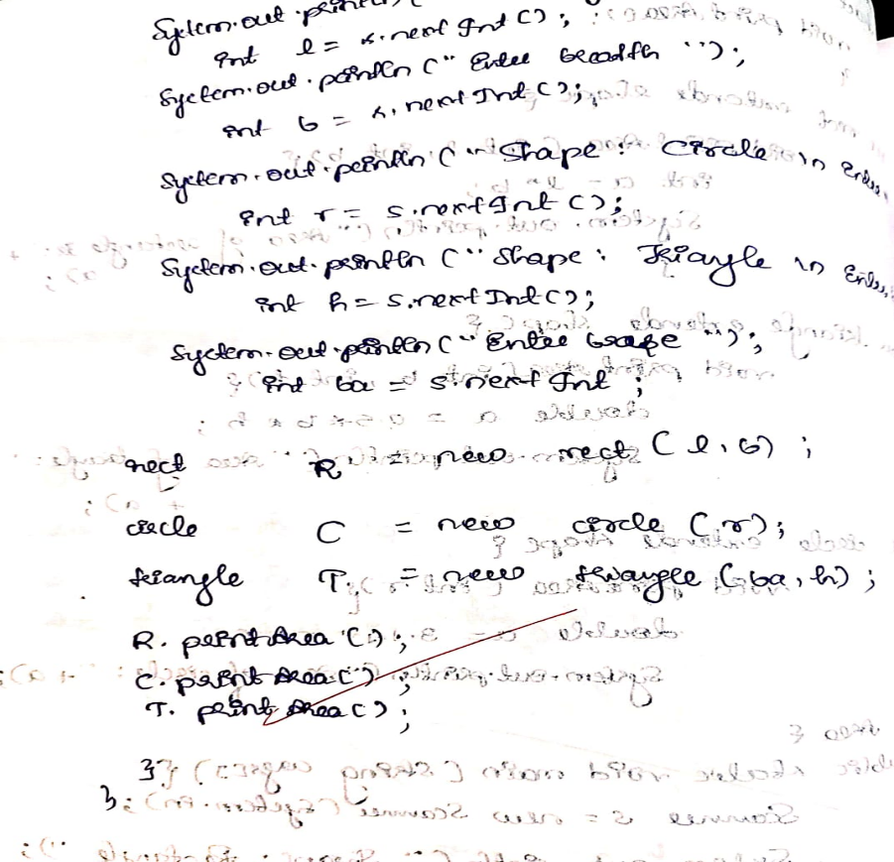

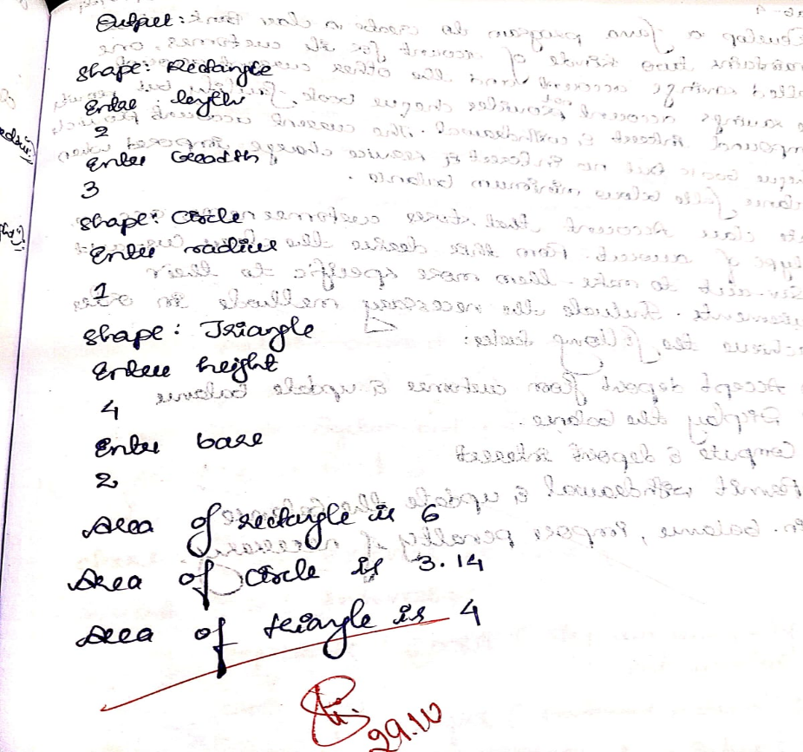

import java.util.Scanner;

abstract class Shape {

    abstract void printArea();

}

class Rect extends Shape {

    private int length;

    private int breadth;

    public Rect(int length, int breadth) {

        this.length = length;

        this.breadth = breadth;

    }

    @Override

    void printArea() {

        int area = length * breadth;

        System.out.println("Area of the rectangle is " + area);

    }

}

class Tri extends Shape {

    private int base;

    private int height;

    public Tri(int base, int height) {

        this.base = base;

        this.height = height;

    }

    @Override

    void printArea() {

        double area = 0.5 * base * height;

        System.out.println("Area of the triangle is " + area);

    }

}

class Circle extends Shape {

    private int radius;

    public Circle(int radius) {

        this.radius = radius;

    }

    @Override

    void printArea() {

        double area = 3.14 * radius * radius;

        System.out.println("Area of the circle is " + area);

    }

}

public class Area {

    public static void main(String[] args) {

        Scanner scanner = new Scanner(System.in);

        System.out.print("Shape: Rectangle\nEnter length: ");

        int length = scanner.nextInt();

        System.out.print("Enter breadth: ");

        int breadth = scanner.nextInt();

        System.out.print("Shape: Triangle\nEnter base: ");

        int base = scanner.nextInt();

        System.out.print("Enter height: ");

        int height = scanner.nextInt();

        System.out.print("Shape: Circle\nEnter radius: ");

        int radius = scanner.nextInt();

        Rect rectangle = new Rect(length, breadth);

        Tri triangle = new Tri(base, height);

        Circle circle = new Circle(radius);

        System.out.println();

        rectangle.printArea();

        triangle.printArea();

        circle.printArea();

        scanner.close();

    }

}

OUTPUT:

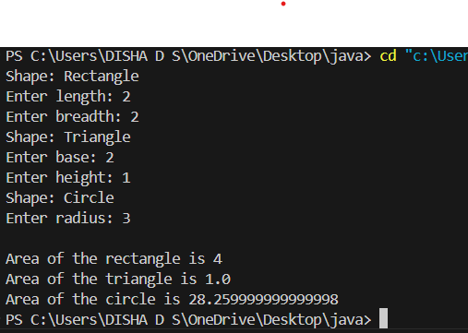

PROGRAM 5

Develop a Java program to create a class Bank that maintains two kinds of account for its customers, one called savings account and the other current account. The savings account provides compound interest and withdrawal facilities but no cheque book facility. The current account provides cheque book facility but no interest. Current account holders should also maintain a minimum balance and if the balance falls below this level, a service charge is imposed. Create a class Account that stores customer name, account number and type of account. From this derive the classes Cur-acct and Sav-acct to make them more specific to their requirements. Include the necessary methods in order to achieve the following tasks: a) Accept deposit from customer and update the balance. b) Display the balance. c) Compute and deposit interest d) Permit withdrawal and update the balance Check for the minimum balance, impose penalty if necessary and update the balance.

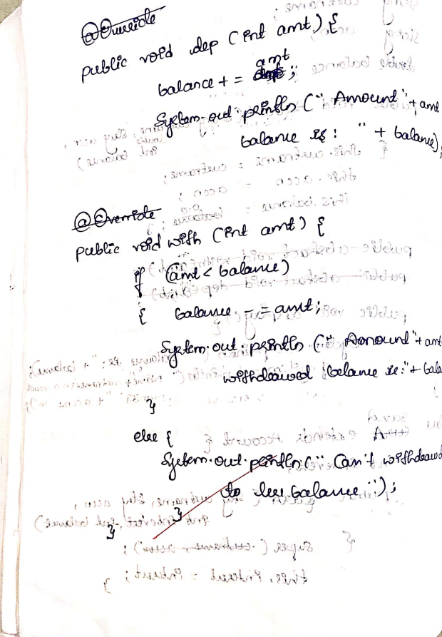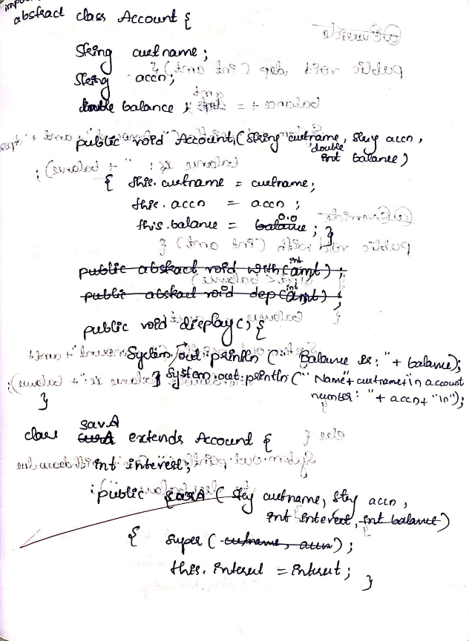

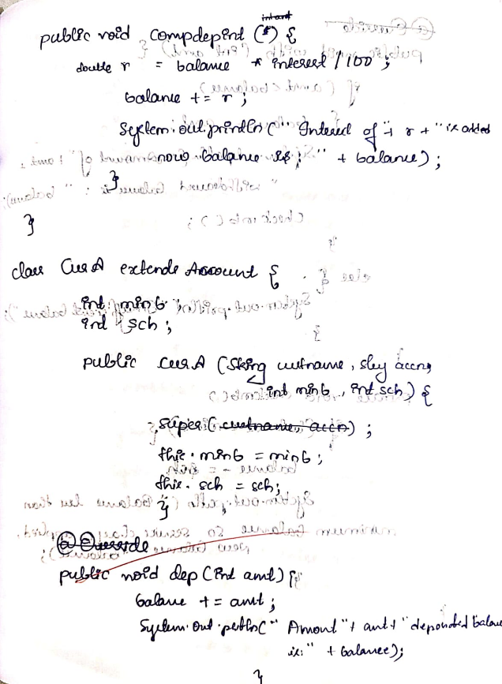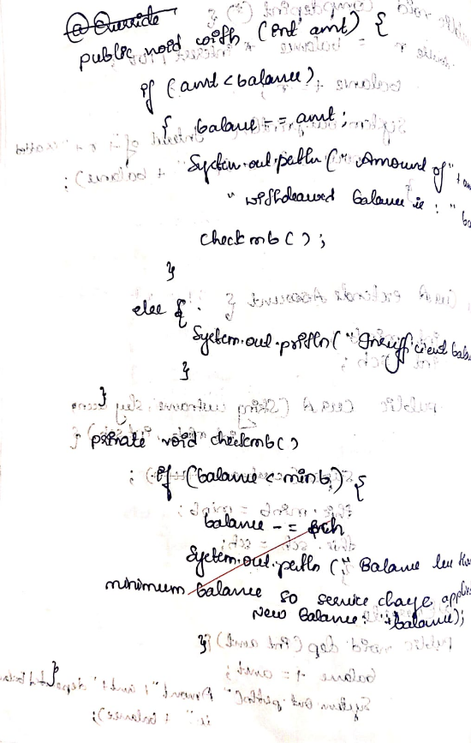

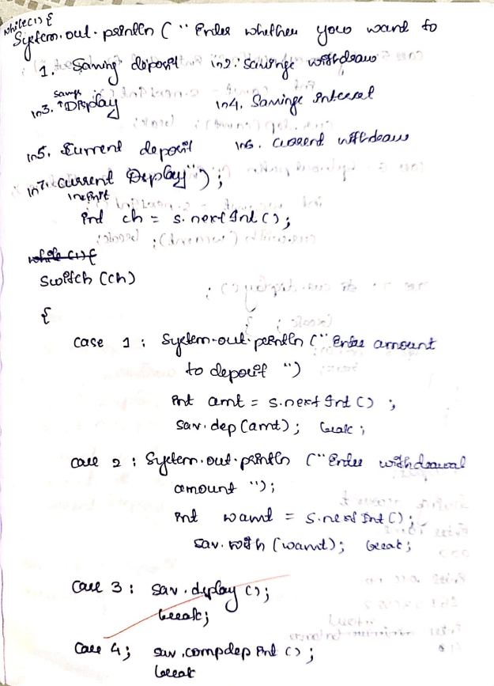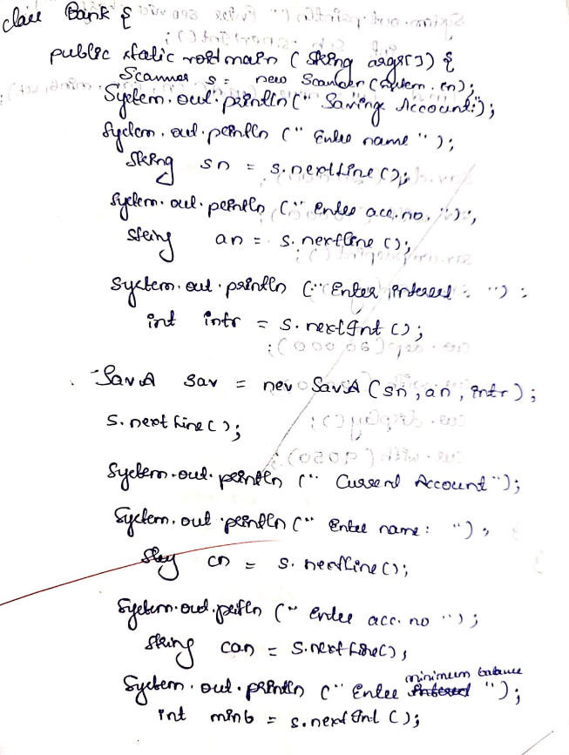

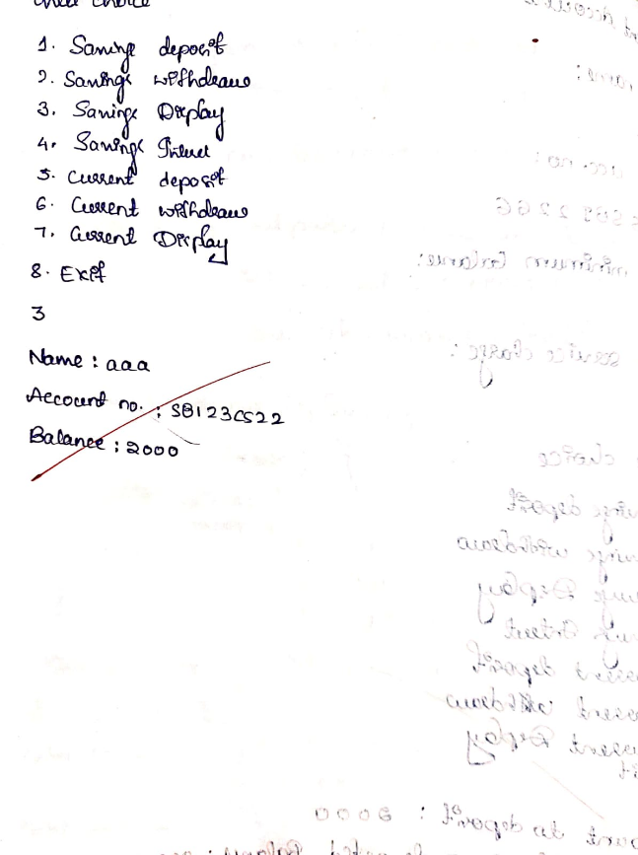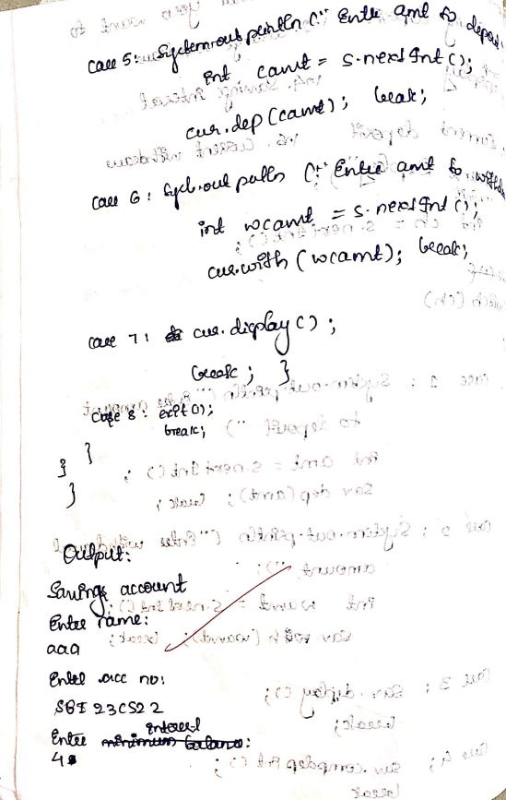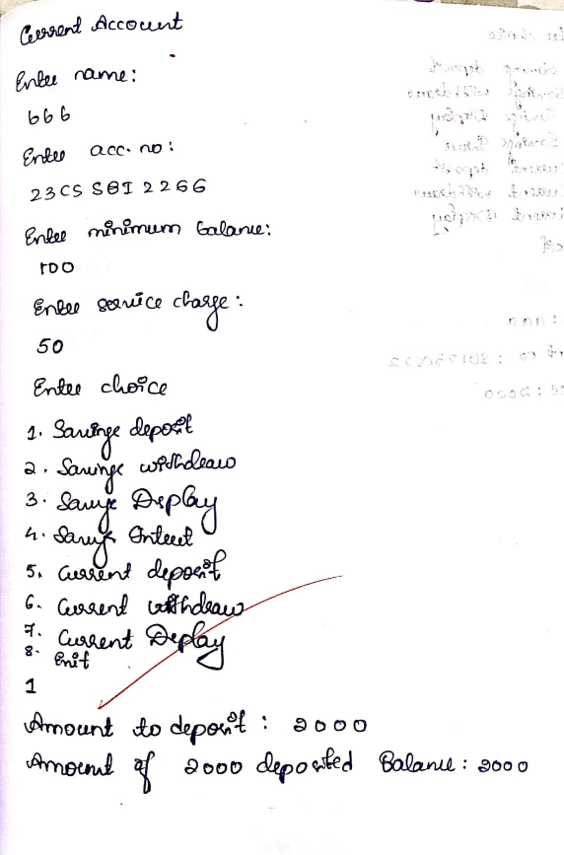

import java.util.Scanner;

class Account {

    String customerName;

    String accountNumber;

    String accountType;

    double balance;

    public Account(String customerName, String accountNumber, String accountType, double initialDeposit) {

        this.customerName = customerName;

        this.accountNumber = accountNumber;

        this.accountType = accountType;

        this.balance = initialDeposit;

    }

    public void deposit(double amount) {

        if (amount > 0) {

            balance += amount;

            System.out.println("Deposit successful. Updated balance: " + balance);

        } else {

            System.out.println("Invalid deposit amount.");

        }

    }

    public void displayBalance() {

        System.out.println("Balance: " + balance);

    }

}

class SavAcct extends Account {

    private static final double INTEREST_RATE = 0.04;

    public SavAcct(String customerName, String accountNumber, double initialDeposit) {

        super(customerName, accountNumber, "Savings", initialDeposit);

    }

    public void computeAndDepositInterest() {

        double interest = balance * INTEREST_RATE;

        balance += interest;

        System.out.println("Interest of " + interest + " deposited. Updated balance: " + balance);

    }

    public void withdraw(double amount) {

        if (amount > balance) {

            System.out.println("Insufficient balance for withdrawal.");

        } else {

            balance -= amount;

            System.out.println("Withdrawal successful. Updated balance: " + balance);

        }

    }

}

class CurAcct extends Account {

    private static final double MINIMUM_BALANCE = 1000.0;

    private static final double PENALTY = 100.0;

    public CurAcct(String customerName, String accountNumber, double initialDeposit) {

        super(customerName, accountNumber, "Current", initialDeposit);

    }

    public void withdraw(double amount) {

        if (amount > balance) {

            System.out.println("Insufficient balance for withdrawal.");

        } else {

            balance -= amount;

            System.out.println("Withdrawal successful. Updated balance: " + balance);

            if (balance < MINIMUM_BALANCE) {

                imposePenalty();

            }

        }

    }

    private void imposePenalty() {

        balance -= PENALTY;

        System.out.println("Balance fell below minimum. Penalty of " + PENALTY + " imposed. Updated balance: " + balance);

    }

}

public class Bank {

    public static void main(String[] args) {

        Scanner scanner = new Scanner(System.in);

        System.out.print("Enter customer name for Savings Account: ");

        String savName = scanner.nextLine();

        System.out.print("Enter account number: ");

        String savAccNum = scanner.nextLine();

        System.out.print("Enter initial deposit: ");

        double savDeposit = scanner.nextDouble();

        SavAcct savings = new SavAcct(savName, savAccNum, savDeposit);

        scanner.nextLine();

        System.out.print("\nEnter customer name for Current Account: ");

        String curName = scanner.nextLine();

        System.out.print("Enter account number: ");

        String curAccNum = scanner.nextLine();

        System.out.print("Enter initial deposit: ");

        double curDeposit = scanner.nextDouble();

        CurAcct current = new CurAcct(curName, curAccNum, curDeposit);

        while (true) {

            System.out.println("\n--- Bank Menu ---");

            System.out.println("1. Deposit to Savings Account");

            System.out.println("2. Withdraw from Savings Account");

            System.out.println("3. Display Savings Account Balance");

            System.out.println("4. Compute and Deposit Interest to Savings Account");

            System.out.println("5. Deposit to Current Account");

            System.out.println("6. Withdraw from Current Account");

            System.out.println("7. Display Current Account Balance");

            System.out.println("8. Exit");

            System.out.print("Enter your choice: ");

            int choice = scanner.nextInt();

            switch (choice) {

                case 1:

                    System.out.print("Enter amount to deposit to Savings Account: ");

                    double savDepositAmt = scanner.nextDouble();

                    savings.deposit(savDepositAmt);

                    break;

                case 2:

                    System.out.print("Enter amount to withdraw from Savings Account: ");

                    double savWithdrawAmt = scanner.nextDouble();

                    savings.withdraw(savWithdrawAmt);

                    break;

                case 3:

                    System.out.println("Savings Account Balance: ");

                    savings.displayBalance();

                    break;

                case 4:

                    savings.computeAndDepositInterest();

                    break;

                case 5:

                    System.out.print("Enter amount to deposit to Current Account: ");

                    double curDepositAmt = scanner.nextDouble();

                    current.deposit(curDepositAmt);

                    break;

                case 6:

                    System.out.print("Enter amount to withdraw from Current Account: ");

                    double curWithdrawAmt = scanner.nextDouble();

                    current.withdraw(curWithdrawAmt);

                    break;

                case 7:

                    System.out.println("Current Account Balance: ");

                    current.displayBalance();

                    break;

                case 8:

                    System.out.println("Exiting program. Thank you!");

                    scanner.close();

                    return;

                default:

                    System.out.println("Invalid choice. Please try again.");

            }

        }

    }

}

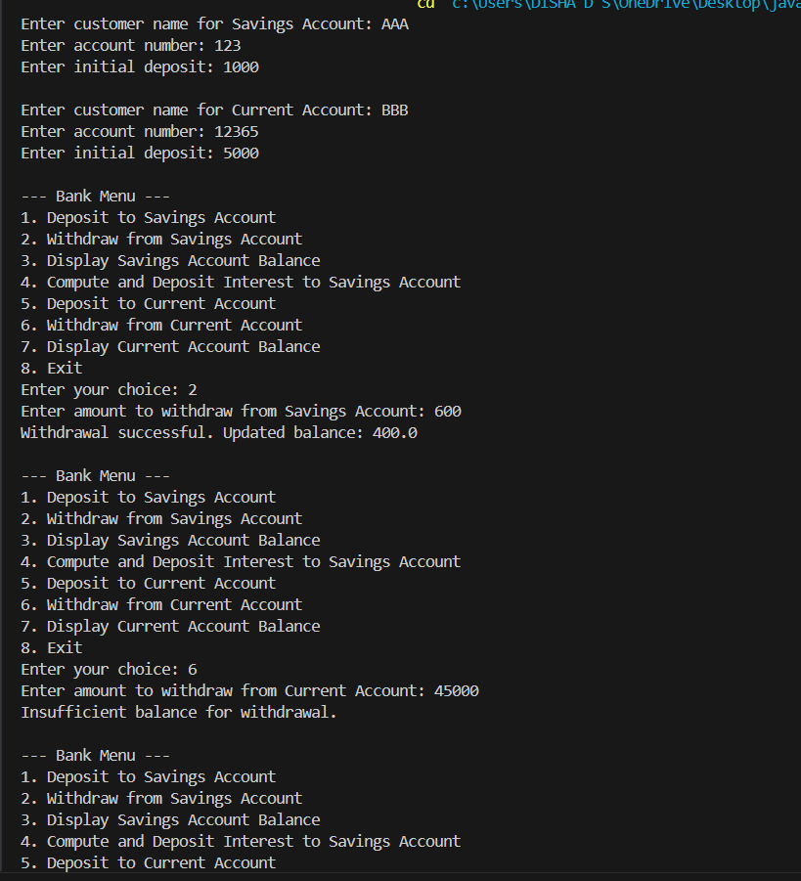

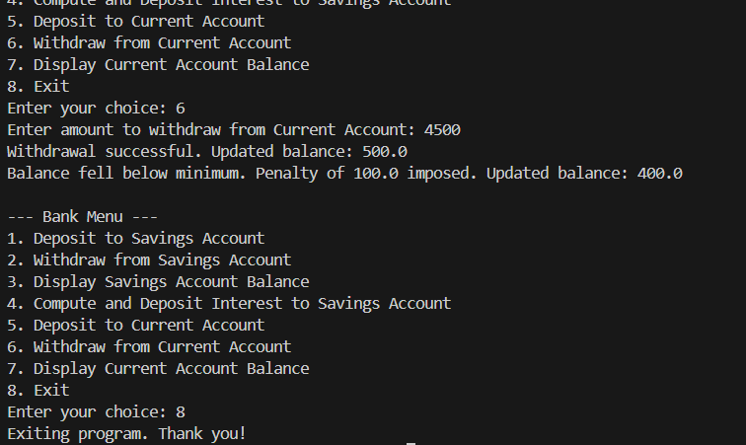

PROGRAM 6

Create a package CIE which has two classes- Student and Internals. The class Personal has members like usn, name, sem. The class internals has an array that stores the internal marks scored in five courses of the current semester of the student. Create another package SEE which has the class External which is a derived class of Student. This class has an array that stores the SEE marks scored in five courses of the current semester of the student. Import the two packages in a file that declares the final marks of n students in all five courses.

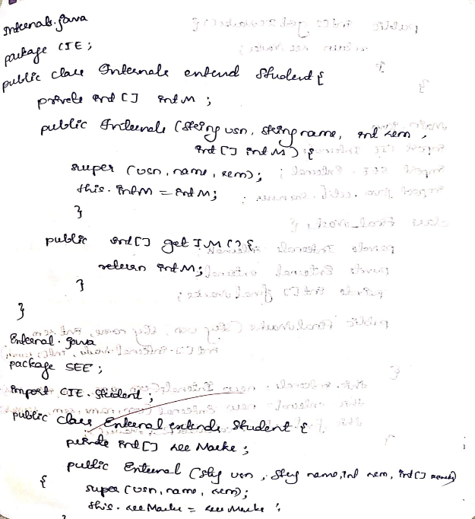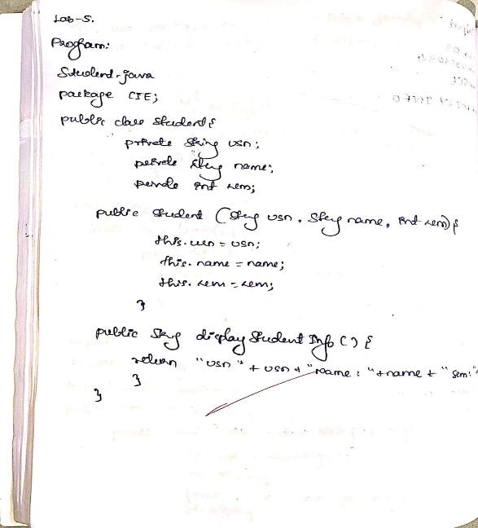

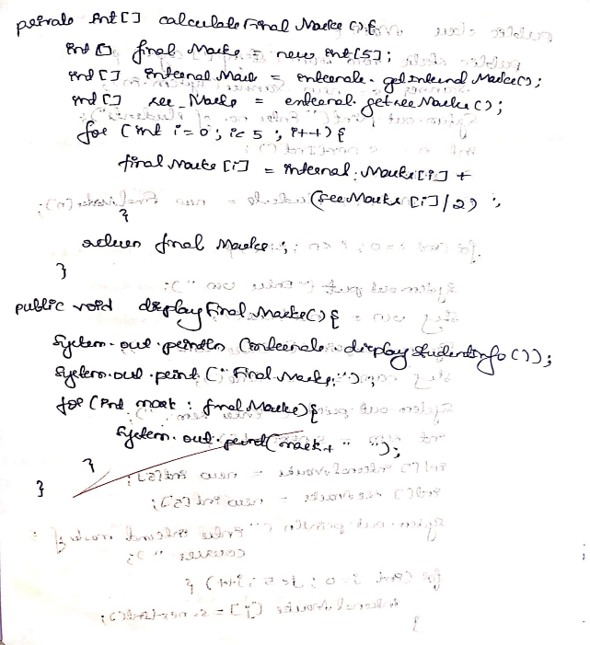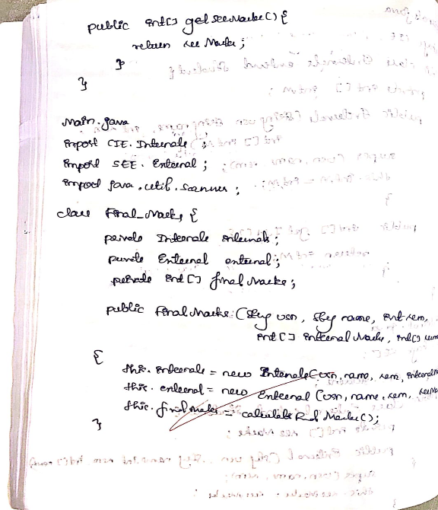

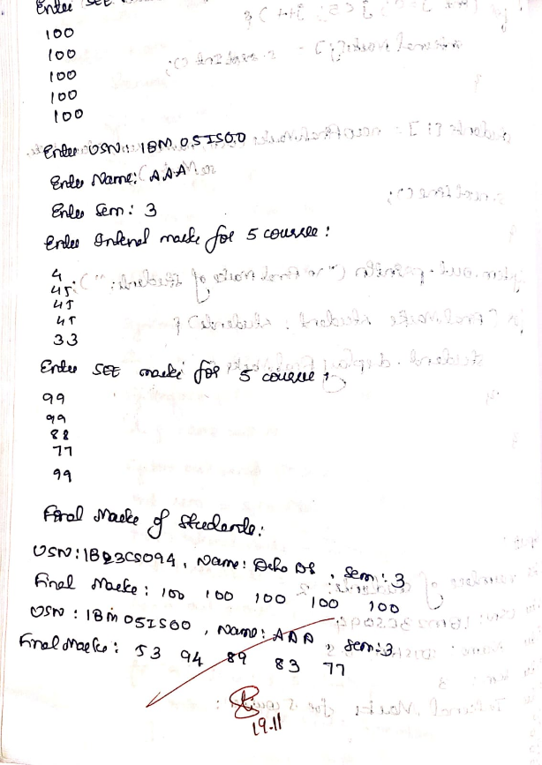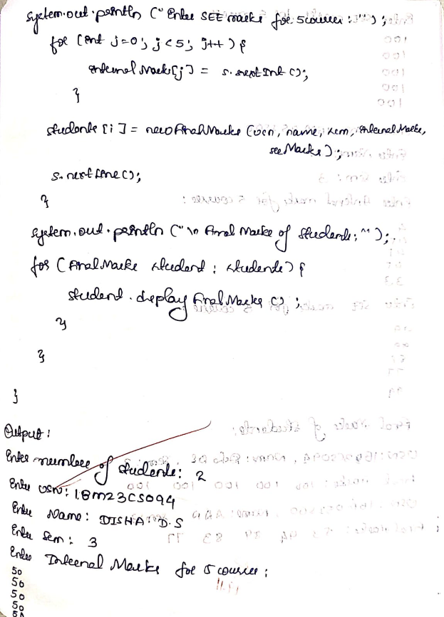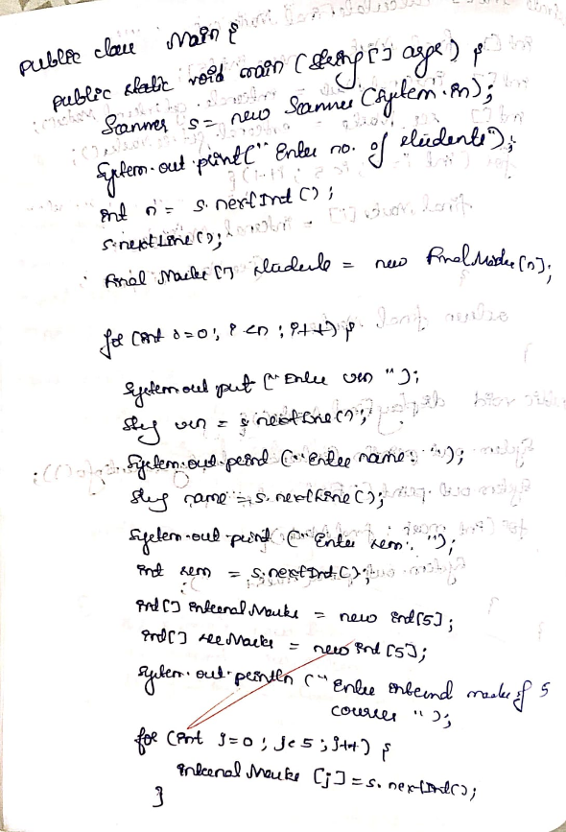

package CIE;

public class Student{

    protected String usn;

    protected String name;

    protected int sem;

    public Student(String usn, String name, int sem) {

        this.usn = usn;

        this.name = name;

        this.sem = sem;

    }

    public String displayStudentInfo() {

        return "USN: " + usn + ", Name: " + name + ", Semester: " + sem;

    }

}

package CIE;

public class Internals extends Student {

    private int[] internalMarks; // Array to store internal marks for 5 courses

    public Internals(String usn, String name, int sem, int[] internalMarks) {

        super(usn, name, sem);

        this.internalMarks = internalMarks;

    }

    public int[] getInternalMarks() {

        return internalMarks;

    }

}

package SEE;

import CIE.Student;

public class External extends Student {

    private int[] seeMarks; // Array to store SEE marks for 5 courses

    public External(String usn, String name, int sem, int[] seeMarks) {

        super(usn, name, sem);

        this.seeMarks = seeMarks;

    }

    public int[] getSeeMarks() {

        return seeMarks;

    }

}

import CIE.Internals;

import SEE.External;

import java.util.Scanner;

class FinalMarks {

    private Internals internals;

    private External external;

    private int[] finalMarks;

    public FinalMarks(String usn, String name, int sem, int[] internalMarks, int[] seeMarks) {

        this.internals = new Internals(usn, name, sem, internalMarks);

        this.external = new External(usn, name, sem, seeMarks);

        this.finalMarks = calculateFinalMarks();

    }

    private int[] calculateFinalMarks() {

        int[] finalMarks = new int[5];

        int[] internalMarks = internals.getInternalMarks();

        int[] seeMarks = external.getSeeMarks();

        for (int i = 0; i < 5; i++) {

            // Assuming final mark is (internal mark) + (SEE mark scaled to 50%)

            finalMarks[i] = internalMarks[i] + (seeMarks[i] / 2);

        }

        return finalMarks;

    }

    public void displayFinalMarks() {

        System.out.println(internals.displayStudentInfo());

        System.out.print("Final Marks: ");

        for (int mark : finalMarks) {

            System.out.print(mark + " ");

        }

        System.out.println();

    }

}

public class Main1 {

    public static void main(String[] args) {

        Scanner s = new Scanner(System.in);

        System.out.print("Enter number of students: ");

        int n = s.nextInt();

        s.nextLine();

        FinalMarks[] students = new FinalMarks[n];

        for (int i = 0; i < n; i++) {

            System.out.print("Enter USN: ");

            String usn = s.nextLine();

            System.out.print("Enter Name: ");

            String name = s.nextLine();

            System.out.print("Enter Semester: ");

            int sem = s.nextInt();

            int[] internalMarks = new int[5];

            int[] seeMarks = new int[5];

            System.out.println("Enter Internal marks for 5 courses:");

            for (int j = 0; j < 5; j++) {

                internalMarks[j] = s.nextInt();

            }

            System.out.println("Enter SEE marks for 5 courses:");

            for (int j = 0; j < 5; j++) {

                seeMarks[j] = s.nextInt();

            }

            students[i] = new FinalMarks(usn, name, sem, internalMarks, seeMarks);

            s.nextLine();  // Consume newline

        }

        System.out.println("\nFinal Marks of Students:");

        for (FinalMarks student : students) {

            student.displayFinalMarks();

        }

    }

}

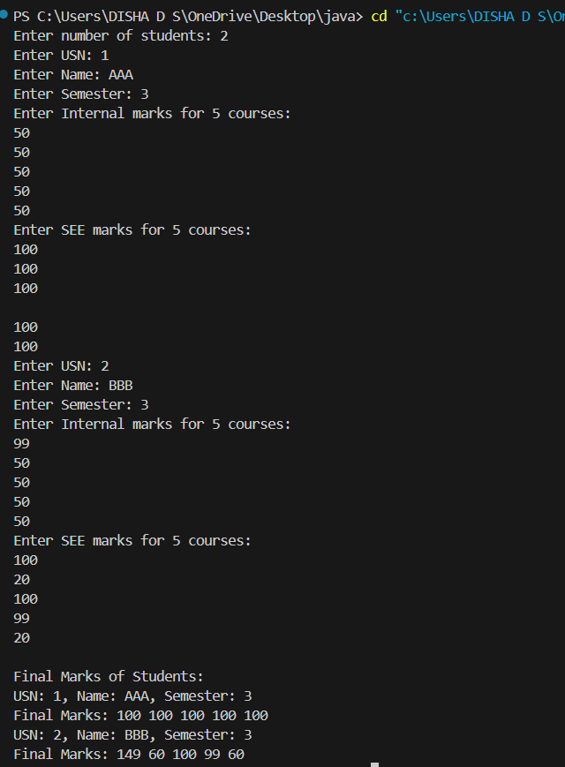OUTPUT

PROGRAM 7

Write a program that demonstrates handling of exceptions in inheritance tree. Create a base class called “Father” and derived class called “Son” which extends the base class. In Father class, implement a constructor which takes the age and throws the exception WrongAge( ) when the input age=father’s age.

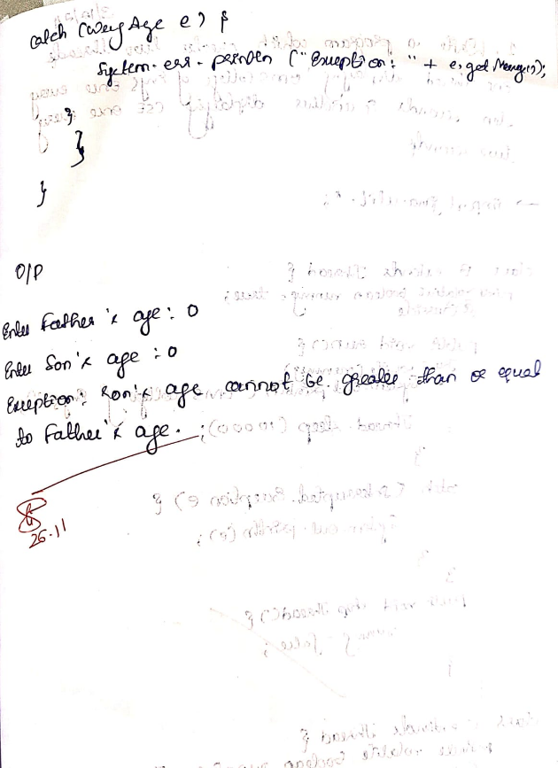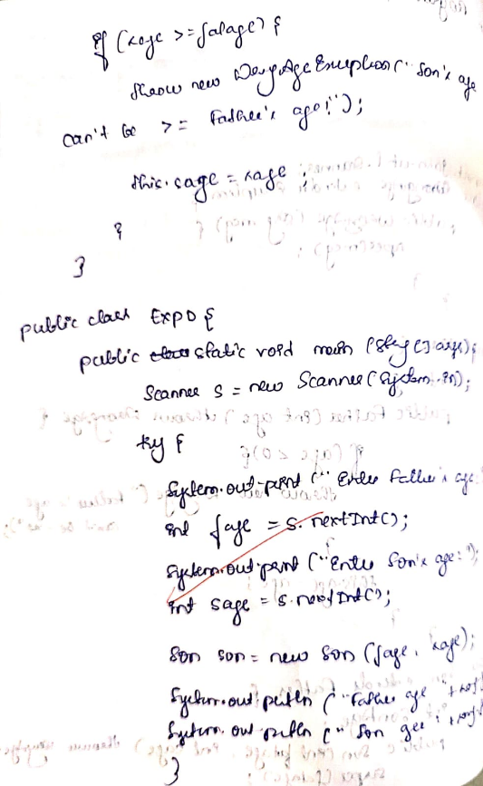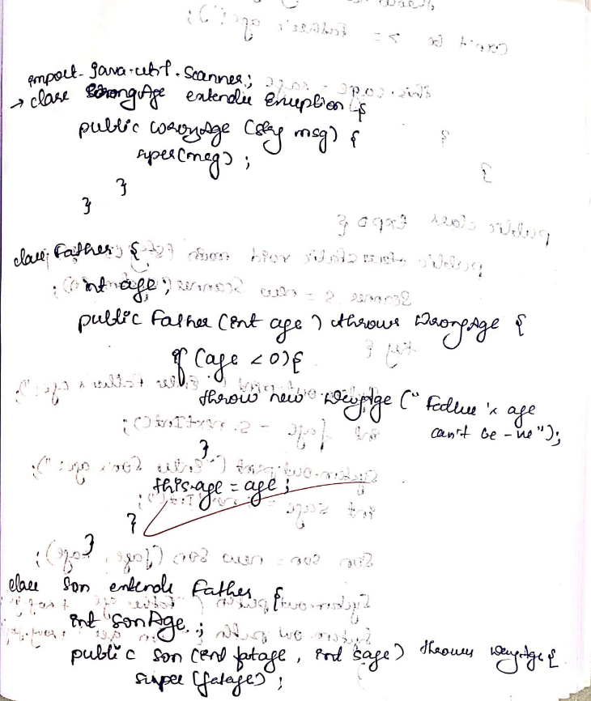

import java.util.Scanner;

class WrongAgeException extends Exception {

    public WrongAgeException(String message) {

        super(message);

    }

}

class Father {

    protected int age;

    public Father(int age) throws WrongAgeException {

        if (age < 0) {

            throw new WrongAgeException("Father's age cannot be negative.");

        }

        this.age = age;

    }

}

class Son extends Father {

    private int sonAge;

    public Son(int fatherAge, int sonAge) throws WrongAgeException {

        super(fatherAge);

        if (sonAge < 0) {

            throw new WrongAgeException("Son's age cannot be negative.");

        }

        if (sonAge >= fatherAge) {

            throw new WrongAgeException("Son's age cannot be greater than or equal to father's age.");

        }

        this.sonAge = sonAge;

    }

    public void displayAges() {

        System.out.println("Father's Age: " + age);

        System.out.println("Son's Age: " + sonAge);

    }

}

public class FamilyAgeTest {

    public static void main(String[] args) {

        Scanner scanner = new Scanner(System.in);

        try {

            System.out.print("Enter father's age: ");

            int fatherAge = scanner.nextInt();

            System.out.print("Enter son's age: ");

            int sonAge = scanner.nextInt();

            Son son = new Son(fatherAge, sonAge);

            son.displayAges();

        } catch (WrongAgeException e) {

            System.out.println("Error: " + e.getMessage());

        } catch (Exception e) {

            System.out.println("Invalid input. Please enter valid ages.");

        }

}}

Output:

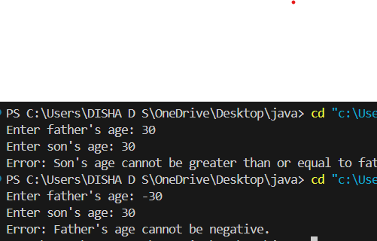

PROGRAM 8

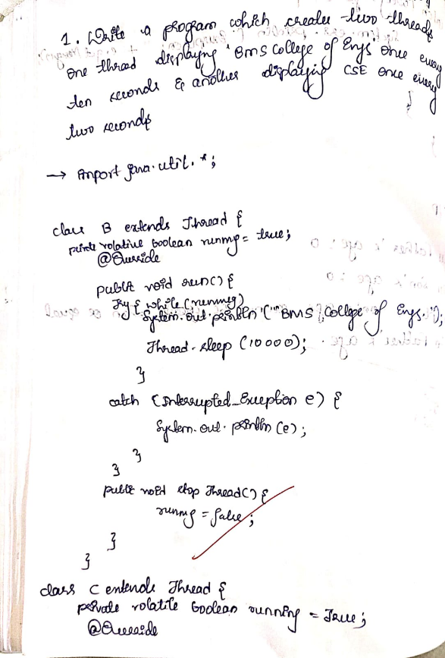Write a program which creates two threads, one thread displaying “BMS College of Engineering” once every ten seconds and another displaying “CSE” once every two seconds.

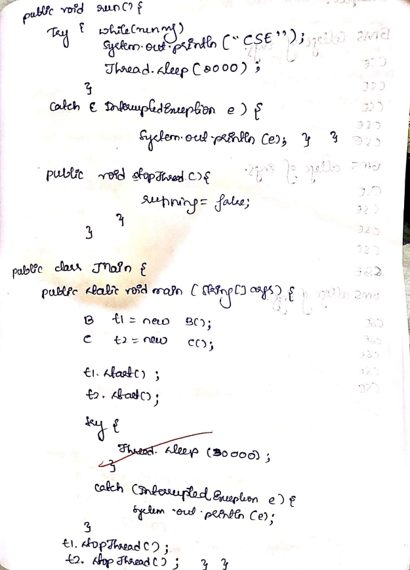

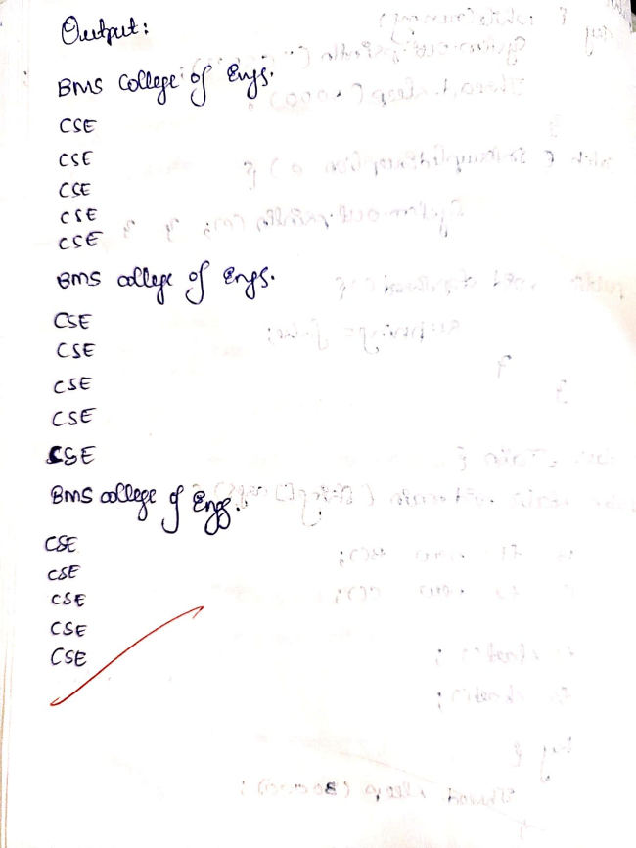

class B extends Thread {

private volatile boolean running = true;

@Override

public void run() {

try {

while (running) {

System.out.println("BMS College of Engineering");

Thread.sleep(10000);

}

} catch (InterruptedException e) {

System.out.println(e);

}

}

public void stopThread() {

running = false;

}

}

class C extends Thread {

private volatile boolean running = true;

@Override

public void run() {

try {

while (running) {

System.out.println("CSE");

Thread.sleep(2000);

}

} catch (InterruptedException e) {

System.out.println(e);

}

}

public void stopThread() {

running = false;

}

}

public class ThreadE {

public static void main(String[] args) {

B thread1 = new B();

C thread2 = new C();

thread1.start();

thread2.start();

try {

Thread.sleep(30000);

} catch (InterruptedException e) {

System.out.println(e);

}

thread1.stopThread();

thread2.stopThread();

}

}

Output

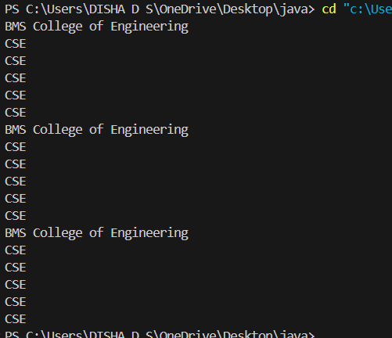

Program 9

Write a program that creates a user interface to perform integer divisions. The user enters two numbers in the text fields, Num1 and Num2. The division of Num1 and Num2 is displayed in the Result field when the Divide button is clicked. If Num1 or Num2 were not an integer, the program would throw a NumberFormatException. If Num2 were Zero, the program would throw an Arithmetic Exception Display the exception in a message dialog box.

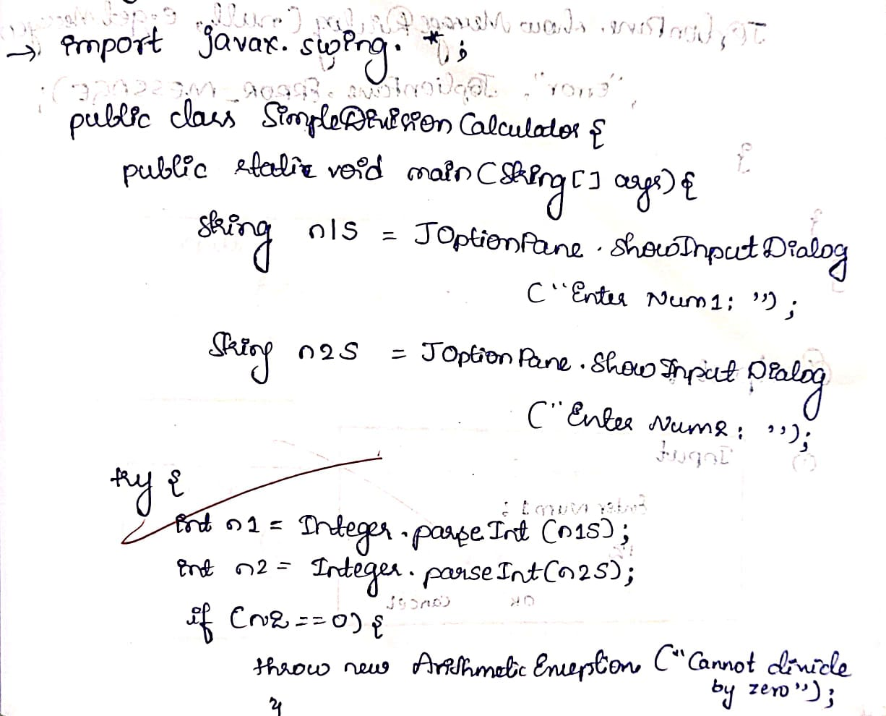

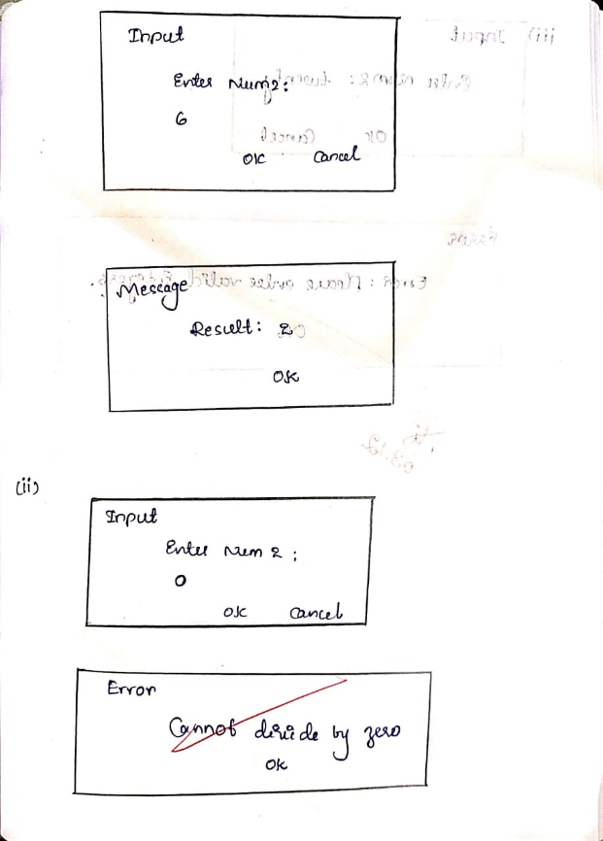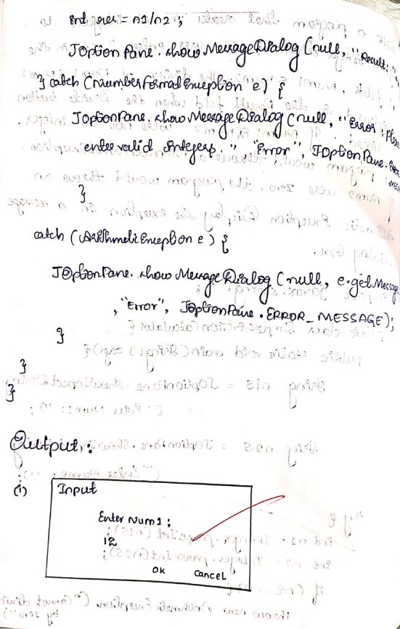

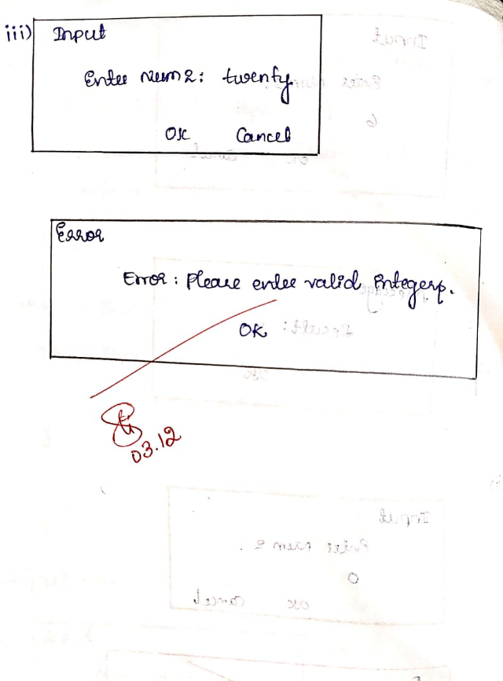

import javax.swing.*;

public class SimpleDivisionCalculator {

    public static void main(String[] args) {

        String num1Str = JOptionPane.showInputDialog("Enter Num1:");

        String num2Str = JOptionPane.showInputDialog("Enter Num2:");

        try {

            int num1 = Integer.parseInt(num1Str);

            int num2 = Integer.parseInt(num2Str);

            if (num2 == 0) {

                throw new ArithmeticException("Cannot divide by zero.");

            }

            int result = num1 / num2;

            JOptionPane.showMessageDialog(null, "Result: " + result);

        } catch (NumberFormatException e) {

            JOptionPane.showMessageDialog(null, "Error: Please enter valid integers.", "Error", JOptionPane.ERROR_MESSAGE);

        } catch (ArithmeticException e) {

            JOptionPane.showMessageDialog(null, e.getMessage(), "Error", JOptionPane.ERROR_MESSAGE);

        }

    }

}

Output:

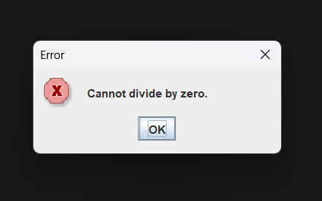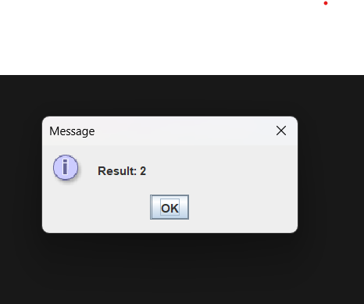

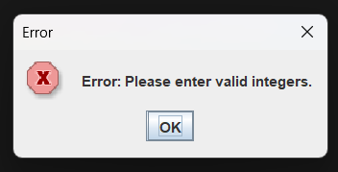

Github link:

<https://github.com/DishaDS094/DISHADS_JAVA_094>